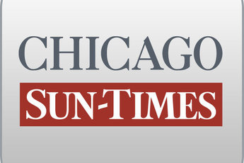
May 02, 2001, WEDNESDAY, Late Sports Final Edition

Ryan denies doling plates to donors

By Dave McKinney
Springfield bureau chief
SPRINGFIELD-Gov. Ryan trashed a government informant in the licenses-for-bribes scandal Tuesday and denied ever trading low-numbered license plates for campaign contributions while secretary of state.

Asked whether his office ever doled out the plates in exchange for political donations, Ryan replied, "Are you a reporter?" When pressed for an answer, Ryan emphatically denied doing that.

"No, absolutely not, never," he said.

Ryan's comments came a day after former secretary of state administrator Larry Hall pleaded guilty to mail fraud and admitted that an unidentified top Ryan aide -- whom prosecutors dubbed "SOS Official A" -- authorized him to exchange prestigious license plates for campaign donations.

Hall's cooperation with federal investigators for the past 18 months has injected a burst of adrenaline into the federal corruption probe of Ryan's old office.
But in his first public comment on the Hall plea, Ryan dwelt not on Hall's cooperation but instead on Hall's admission that he rigged bids and accepted kickbacks while overseeing secretary of state properties in the Chicago area between 1993 and 1998.

"There was a crook who worked in the office who was in business for himself who admitted his guilt, and now he's going to prison, as it should be," Ryan said.

The former chief of staff in the secretary of state's office, Scott Fawell, said through a spokesman that he was unaware of any trading of low-digit license plates for campaign contributions in the secretary of state's office.

In the plea agreement disclosed Monday, Hall said plates and other favors were traded in exchange for $ 10,700 in political donations to three campaign funds. Those funds belonged to Ryan, former secretary of state candidate Al Salvi, and Senate President James "Pate" Philip, sources said.

Philip (R-Wood Dale) refused to say whether he was asked about Hall by federal investigators during an interview in late March.

The Senate leader, who received $ 1,400 from Hall while he was cooperating with federal authorities, also denied working through Hall to obtain license plates for donors or knowing him well, even though he is from Wheaton.

"Never met him until he got a (state) job, period," Philip said.

Former state treasurer Pat Quinn said Tuesday that low-digit license plates should be auctioned to the highest bidder.

Selling the coveted plates -- numbers 1 through 9999, as well as those with just one, two or three letters -- could raise money to promote organ donations, Quinn said in a petition to Secretary of State Jesse White.

White is considering auctioning the plates to the highest bidder or doling them out through a lottery, his spokesman David Druker said.

"If you just do an auction, it's only limited to the wealthy," Druker said. "We're intrigued by Pat's proposal to have the money go to organ donations."
Contributing: Tim Novak

