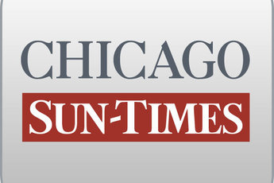
January 15, 2002 Tuesday

O'Malley blames Gov. Ryan for bribes, 6 kids' deaths linked to bribes Gov. Ryan O'Malley ad says 6 kids died due to Gov. Ryan

By Dave McKinney and Scott Fornek
Staff reporters
Hoping to stake himself out as the anti-George Ryan candidate, Republican gubernatorial hopeful Patrick J. O'Malley unveiled a television commercial Monday that blamed the outgoing GOP governor for the deaths of six children linked to the commercial driver's license scandal.

"Licenses that sold for bribes fed George Ryan's election, and children died," the narrator says in the 30-second commercial.

In the harshest ad yet in the GOP primary contest, O'Malley tells viewers that "from O'Hare to taxes, Gov. Ryan has broken every campaign promise."

Ryan spokesman Dennis Culloton said, "It's outrageous. It doesn't dignify a response. It doesn't do any justice to the victims, and it's just the kind of crazed rantings you'd expect from that camp these days."

Ryan announced last year that he would not seek another term, but O'Malley told reporters "he may not be running again, but make no mistake about it: George Ryan is what this campaign's about, and he's a big issue."

"Let's be frank about something," said O'Malley, a state senator from southwest suburban Palos Park. "George Ryan's legacy as governor--and as a Republican governor--is one of lies, betrayals and corruption."

The commercial, scheduled to hit Chicago area airwaves today in a $180,000-a-week purchase, makes no mention of O'Malley's chief primary rivals--Attorney General Jim Ryan or Lt. Gov. Corinne Wood--but O'Malley told reporters neither is "free from the stain of George Ryan."

O'Malley said that, as George Ryan's running mate in 1998, Wood benefitted from his campaign fund, which contained contributions linked to bribes taken by secretary of state workers. And O'Malley called Jim Ryan "an apologist frankly by his failure to act" to root out corruption as the state's top law enforcement official.

O'Malley sidestepped questions about whether George Ryan is directly responsible for the deaths of the six Willis children, who were killed in a fiery 1994 crash by a trucker who obtained his license with help from an intermediary who bribed a secretary of state employee.

Wood spokeswoman Tressa Pankovits said Wood took $10,000 in donations from George Ryan, but repaid the amount before the election. "Pat O'Malley is clearly addicted to the sensational," Pankovits said. "He plays fast and loose with the facts."

Dan Curry, a spokesman for Jim Ryan, said the attorney general is not an apologist for anyone and has aggressively pursued public corruption cases. "It would [have been] inappropriate and counterproductive for the attorney general's office to have conducted a parallel investigation [to the federal probe,]" Curry said.

