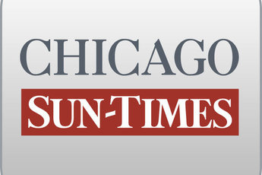
August 24, 2014 Sunday

Feds subpoena emails of Quinn's ex-chief of staff

By Dave McKinney
Springfield bureau chief
SPRINGFIELD - Federal prosecutors have subpoenaed the emails of Gov. Pat Quinn's former chief of staff, another former high-level aide and an ex-state commerce official as part of the ongoing investigation into the governor's Neighborhood Recovery Initiative anti-violence grant program.

The governor's office released two subpoenas, both dated July 28, from the federal prosecutor in Springfield who's heading the probe, which has become an issue in Quinn's re-election campaign.

One of the subpoenas seeks emails dating to January 2010 for former Quinn chief of staff Jack Lavin, former senior adviser Billy Ocasio and Andrew Ross, onetime chief operating officer of the state Department of Commerce and Economic Opportunity.

Ocasio is misidentified on the subpoena as "Robert Occasion," but a Quinn spokesman said Saturday the governor's staff consulted with the U.S. attorney's office and confirmed prosecutors were referring to Ocasio.

The second subpoena seeks records dating to January 2010 on another anti-violence grant program, the Safety Networks Initiative, run by the state Department of Human Services and involving the Illinois Violence Prevention Authority and Criminal Justice Information Authority.

A Quinn spokesman said the records being sought by prosecutors are records the governor's office already was asked to provide to the Legislative Audit Commission as part of its ongoing probe spurred by a February audit of the Neighborhood Recovery Initiative by state Auditor General William Holland.

"The governor has zero tolerance for any mismanagement and took decisive action to fix the problems long ago," Quinn spokesman Grant Klinzman said Saturday, repeating the stance Quinn has taken since the first word of the NRI probes. "The program has been shut down for nearly two years, we enacted legislation that would make Illinois a national leader for grant oversight, and the governor has ordered all state agencies to fully support any inquiries. If any grantee has done anything wrong, they should be held fully accountable."

